|  |  |  |
| --- | --- | --- |
| C:\Users\Administrator\Desktop\AU.png | Development of IOT Device for Shared E-Vehicle | \\10.2.9.4\Faculty\MKS\Department\General\KSRCT_LOGO.jpg |

A PROJECT REPORT

Submitted by

chanduru v M

PRABAKARAN S K

ARAVIND S

KAVIN A

in partial fulfillment of the requirement

for the award of the degree

of

BACHELOR OF ENGINEERING

in

DEPARTMENT OF MECHATRONICS ENGINEERING

K.S. RANGASAMY COLLEGE OF TECHNOLOGY

(An Autonomous Institution, affiliated to Anna University Chennai and Approved by AICTE, New Delhi)

TIRUCHENGODE – 637 215

July 2022

K.S. RANGASAMY COLLEGE OF TECHNOLOGY

TIRUCHENGODE - 637 215

BONAFIDE CERTIFICATE

Certified that this project report titled “DEVELOPMENT OF IoT DEVICE FOR SHARED E-VEHICLE” is the bonafide work of **CHANDURU V M (1815105), PRABAKARAN S K (1815121), ARAVIND S (1815102),** and **KAVIN A (18151403)** who carried out the project under my supervision. Certified further, that to the best of my knowledge the work reported herein does not form part of any other project report or dissertation on the basis of which a degree or award was conferred on an earlier occasion on this or any other candidate.

|  |  |
| --- | --- |
| SIGNATURE  Dr. N.Thiruvenkadam, M.E., Ph.D.,  professor & HEAD  Department of Mechatronics  K.S. Rangasamy College of Technology  Tiruchengode - 637 215 | SIGNATURE  Mr. R.Vivek, M.E.,  SUpervisor  Assistant Professor,  Department of Mechatronics  K.S. Rangasamy College of Technology  Tiruchengode - 637 215 |

Submitted for the viva-voce examination held on ………………

**Internal Examiner External Examiner**

DECLARATION

We jointly declare that the project report on “DEVELOPMENT OF IOT DEVICE FOR SHARED E-VEHICLE” is the result of original work done by us and best of our knowledge, similar work has not been submitted to “ANNA UNIVERSITY CHENNAI” for the requirement of Degree of Mechatronics. This project report is submitted on the partial fulfilment of the requirement of the award of Degree of Mechatronics.

|  |
| --- |
| **Signature** |
| \_\_\_\_\_\_\_\_\_\_\_\_\_\_\_\_\_\_\_\_  CHANDURU V M |
| \_\_\_\_\_\_\_\_\_\_\_\_\_\_\_\_\_\_\_\_  PRABAKARAN S K |
| \_\_\_\_\_\_\_\_\_\_\_\_\_\_\_\_\_\_\_\_  ARAVIND S |
| \_\_\_\_\_\_\_\_\_\_\_\_\_\_\_\_\_\_\_\_  KAVIN A |

Place: Tiruchengode

Date:

ACKNOWLEDGEMENT

We wish to express our sincere gratitude to our honourable Correspondent Lion Dr. K. S. RANGASAMY, M.J.F., for providing immense facilities at our institution.

We would like to express special thanks of gratitude to our Chief Executive Officer **Dr. K. THYAGARAJAH, M.E.,** **Ph.D.,** who has been the key spring of motivation to us throughout the completion of our course and project work.

We are very proudly rendering our thanks to our Principal   
Dr. R. GOPALAKRISHNAN, M.E., Ph.D., for the facilities and the encouragement given by him to the progress and completion of our project.

We proudly render our immense gratitude to the Head of the Department **Dr.N.THIRUVENKADAM, M.E.,Ph.D.,** for his effective leadership, encouragement and guidance in the project.

We are highly indebted to provide our heart full thanks to our supervisor **Mr.R.VIVEK, M.E.,** for his valuable ideas, encouragement and supportive guidance throughout the project.

We wish to extend our sincere thanks to all faculty members of our Mechatronics Department for their valuable suggestions, kind co-operation and constant encouragement for successful completion of this project.

We wish to acknowledge the help received from various Departments and various individuals during the preparation and editing stages of the manuscript.

Additionally, We would like to express gratitude to IDEA laboratory for the treasured support which was really influential in shaping my experiment methods and critiquing my results

ABSTRACT

With the Internet of things (IoT) and EV Shared mobility evolving in the recent times, the need for easy and user-friendly self driving system is being a great challenge to be developed. The proposed methodology involves use of smart card (RFID) system integrated with GSM system and handling the data in the database. The system allows the user to Register their details in the database and the card is been assigned to the particular user. This allows anyone to drive any vehicle with the registered card. The location of each vehicle is been updated to the server using GPS and the battery level of each vehicle is also updated to the server. The user will able to recharge the card in the website through UPI, even though the current IoT enabling technologies have greatly improved in the recent years, there are still numerous problems that require attention this system eliminates the need of smartphone use to access the vehicle. Thus, providing data security to the user

TABLE OF CONTENTS

CHAPTER TITLE PAGE NO.

ABSTRACT v

LIST OF TABLES viii

LIST OF FIGURES ix

1. INTRODUCTION 1

1.1 Radio Frequency Identify 1

1.2 Micro-mobility services 3

1. LITERATURE REVIEW 4

2.1 Radio Frequency Identify 4

2.2 Embedded system 6

1. MATERIALS AND METHODS 8

3.1 DC motor 8

3.2 GSM module 9

3.3 ESP 8266 10

3.4 relay 10

3.5 rFID 11

3.6 LCD 12

3.7 SOFTWARE REQUIRED 13

1. EXPERIMENTAL SETUP AND PROCEDURE 14

4.1 OVERVIEW OF IOT 14

4.2 FUNCTIONALITY PERFORMED BY USERS 15

4.3 PROCESS FLOW DIAGRAM FOR IOT 20

1. RESULTS AND DISCUSSION 21
2. CONCLUSION 22

APPENDIX 1 23

APPENDIX 2 24

REFERENCES 25

LIST OF TABLES

|  |  |  |
| --- | --- | --- |
| **TABLE NO.** | **TITLE** | **PAGE NO.** |
| 2.1 | Basic range of RFID | 4 |
|  |  |  |
|  |  |  |
|  |  |  |

LIST OF FIGURES

|  |  |  |
| --- | --- | --- |
| **FIGURE NO.** | **TITLE** | **PAGE NO.** |
| 1.1 | Barcode Vs RFID | 2 |
| 2.1 | A Schematic of Power and Data Flow in a UHF RFID System | 5 |
| 2.2 | Passive RFID System | 6 |
| 2.3 | Active RFID System | 6 |
| 2.4 | Embedded System Design Process | 7 |
| 3.1 | DC Motor | 8 |
| 3.2 | GSM Module | 9 |
| 3.3 | ESP 8266 | 10 |
| 3.4 | Relay | 11 |
| 3.5 | Radio Frequency Identify | 12 |
| 3.6 | LCD | 13 |
| 4.1 | Overview of IoT | 14 |
| 4.2 | Admin Panel Login System | 15 |
| 4.3 | Reset Admin Account Password | 16 |
| 4.4 | View and Manage Users | 16 |
| 4.5 | User Management System | 17 |
| 4.6 | Enroll New Users/Update/Remove | 17 |
| 4.7 | Device Management System | 18 |
| 4.8 | Add New RFID Scanner Device | 18 |
| 4.9 | View Users log | 19 |
| 4.10 | Filter Users Log to export | 19 |
| 4.11 | Process Flow Diagram | 20 |

# CHAPTER 1

INTRODUCTION

## Radio frequency identify

Radio Frequency Identify (RFID) are emerging as a powerful technique for organizations to implement business processes through selecting and combining Web Services according to the business tasks. There is a strong need to promote businesses integration in RFID applications. One of the major topics is how to efficiently and reliably develop and build business solutions through the integration of RFID applications and existing systems. The main objective of this report is to propose a service composition framework that adopts a web services-based approach to integrate RFID business solutions.

Radio Frequency Identify (RFID) is a wireless and contact-less system and it is one of the emerging technologies offering a solution, which can facilitate automation. RFID is a killer technology that elegantly provides a solution to wide range of business needs. And it is one of methods to build ubiquitous environments. Ubiquitous computing means the change in computer and network application environments from limited office areas to various spaces. RFID technology has been focused as a key technology in the implementation of ubiquitous computing. Ubiquitous environments can expand the enterprise business. In this report provide an example to discuss how to use RFID to expand the business and strategy alliances.

Enterprises are looking for most cost-effective and efficient way to solve currently identified business issues, as well as looking at as yet unsolved problems and are trying to determine how to apply RFID technology to solve these new problems. The role of RFID solution as a responsible and socially aware technology is to lead enterprises toward solving these existing problems. RFID technologies with the appropriate IS/IT infrastructure help major distributors and manufacturers, as well as other logistics operations.

There is a question. Why use RFID not barcode? Longer read range, multiple read and larger data capacity are the difference of RFID and barcode. And the RFID tag is difficult to copy (see Figure 1.1). But the deployment cost is high. RFID will also help companies get real-time information about operations, and help them improve their business process. So, there are some advantages and disadvantages between RFID and barcode. This report did not discuss the advantages and disadvantages directly, because it is depending on you how to create the operation model and application strategy.

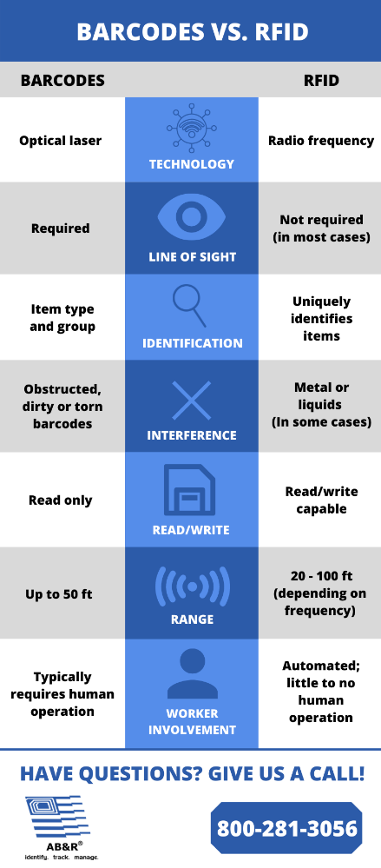

**Figure 1.1 Barcode Vs RFID**

Web services infrastructures have grown both in scale and in cope and are increasingly used to support all information system. This case use RFID combine the web services technology to expand the enterprise’s business and the focus is not on the system coding. In this case study, we first considered a business model for the bike rental. The business model strategy and goals are automatic, convenient, quickly, reduce manpower, and integrated information system, finally strategic alliance with other bike rental stores and different class of businesses. Applications can be written against a business operation model and deployed on an evolving device infrastructure. A prototype shows that the approach facilitates the management and programming of an RFID infrastructure. At the core of our methodology is a model that captures the RFID infrastructure, IT platform, business operation structure, and the relationship between them. Using this model, we describe a management system that supports common management tasks. Similarly, an application framework can be created easy for solution developers to create distributed RFID applications in other companies or branches

In this report we first considered a business model for the bike renting store. This business model strategy and goals are automatic, convenient, quickly, reduce manpower, and integrated information system, finally strategic alliance with other bike renting stores. Second, we construct architecture about hardware and software, when a strategy had been planned. Due to the RFID feature, result in many constrains and problems. So in this phase, we must consider how to avoid those constrains. Finally started to develop and deploy applications (APs).

## Micro-Mobility Services

“Micro-mobility” generally refers to a family of relatively small, lightweight personal mobility devices currently available on the market, which range from human-powered to electric-assisted to fully electric powered. These include conventional bicycles, electric “pedal-assist” bicycles, electric “throttle-driven” bicycles, electric kick-style scooters, electric seated mobility scooters, and many others. This report is focused on three types of micro-mobility devices: non-assisted conventional bicycles, electric pedal-assist bicycles, and electric kick-style scooters. Shared micro-mobility is when a service is provided for users to rent a vehicle for a short period of time for a point-to-point trip.

Staff have provided two previous reports to Council regarding micro-mobility. In October 2019, a report titled “Bikes, E-bikes and E-scooters: Expanding Mississauga’s Transportation Options” from the Commissioner of Transportation and Works was received by General Committee and Council. This report provided a high-level snapshot of the state of the shared micro-mobility industry, and recommended that Mississauga move forward with establishing a framework for a phased introduction of shared micro-mobility services.

In December 2020, a report titled “Vision and Interim E-scooter Strategy” from the Commissioner of Transportation and Works was received by General Committee and Council which provided an overview of staff’s vision for shared micro-mobility services in Mississauga. The vision consists of eight strategic pillars:

● Accessibility and ease of use;

● Addressing climate change;

● Build sense of community;

● Education;

● Leverage and partner with business;

● Mobility and a service;

● Safety;

● Supporting infrastructure and policies.

LITERATURE REVIEW

## Radio Frequency Identification

In this world, there are a lot of methods can be used to transfer a data. One of them is using radio frequency electromagnetic field. The famous tool that use this method is Radio Frequency Identification (RFID). It is the wireless non-contact devices created for the purpose of automatically identifying and tracking the information inside programmable tags or card. The tags or card have an ability to read at a short range via magnetic field that also call as electromagnetic induction. Then, it will act as a passive transponder to emit microwaves or UHF radio waves. On the other hand, the limitation of other automatic identification approach which are used light to communicate (infrared and bar codes technology) can be overcomes from this technology. It is proven when the RFID tag or card are invisible to the eye and can be used in dirty environment. Without labour-intensive manual scanning, RFID readers can be set to remotely and automatically read. Radio frequency of this system can be categorised into four basic range and are given in Table 1 below:

**Table 2.1**: Basic range of RFID

|  |  |  |  |
| --- | --- | --- | --- |
| **Symbol** | **Type of Frequency** | **Range** | **Uses** |
| LF | Low Frequency | 30 kHz to  300 kHz | 125 kHz |
| HF | High Frequency | 3 MHz to  30 MHz | 13.56 MHz |
| VHF | Very  High Frequency | 30 MHz to  300 MHz | Not used for RFID |
| UHF | Ultra-High Frequency | 300 MHz to 3 GHz | 866 MHz, 915  MHz |

Basically, there are two components that involve in RFID system which are RFID reader and RFID tags. The system contains a coil that act as antenna for transmitting and receiving signal as shown in **Figure 2.1**. In the same time, the signal can store maximum 2 kilobytes of data. Similar concept is implemented for all type of RFID system. At first, radio wave will be generated from RFID reader and after that, the RFID tag will reflect back the radio waves by using backscatter technology. From that, data has been sent to the reader by combining them with the radio waves through modulation.

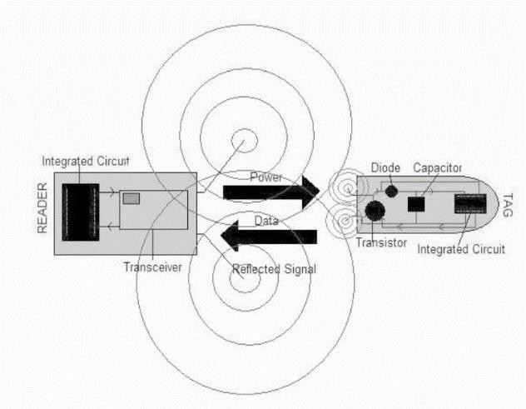

**Figure 2.1: A Schematic of Power and Data Flow in a UHF RFID System**

The substances used to store some additional information and unique serial number is a silicon microchip that fabricate inside the majority of RFID tags or transponders. RFID system can be categories into two part which are passive (**Figure 2.2**) and active (**Figure 2.3**). There are a fundamentally different technologies in Active RFID and Passive RFID but both of them used the same medium to communicate between a reader and a tag or card which is radio frequency energy. It’s different can be seen in the method of powering the tag or card. For Active RFID, internal power source are used to continuously power the tag and its RF communication circuitry, whereas Passive RFID totally used the RF energy transferred from reader to the tag. So that, stronger signal are required from reader for Passive RFID in order to increase the signal strength returned from the tag. So that, stronger signal are required from reader for Passive RFID in order to increase the signal strength returned from the tag. On the other hand, Active RFID have more effective tag that can generate high level- signal back to the reader and also continuously powered whether in reader field or not.

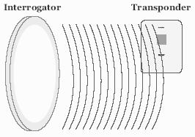 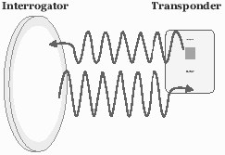

**Figure 2.2: Passive RFID System** **Figure 2.3: Active RFID System**

## Embedded System

IC designers state that microprocessor based design is an important design discipline since 1990s. According to Moore’s Law, 16-bits and 32-bits microprocessor chips that already had been used in board-level design have a large enough to include both a CPU and other subsystem. Resulting from that, two classes of problem have been identify which are the software must become a first class component in chip design and large predesigned of CPU must handled by the system design methodologies. Hence, the root of Hardware/Software Co-design had been formed from the development done by the researchers in basic approaches to the design of embedded software running on CPU.

Embedded system can be define as ‘hardware embedded with software’. All the hardware components are controlled by a microcontroller with a special software. Traditionally, there are three phases on designing an embedded system. First, decomposing and allocating the system into two part which are hardware and software. Second, separate hardware and software design team according to their specialization and lastly, integrating both hardware and software simultaneously. This separation of design task can prevent any mistakes in designing until integration phase happen where each mistakes are very costly and difficult to correct.

Based on the paper written by Claudio Talarico, Aseem Gupta, Ebenezer Peter, and Jerzy W. Rozenblit with title Embedded System Engineering Using C/C++ Based Design Methodologies, for describing hardware and software, they had addressed this issue by using the same high-level language which are C and C++ in order to keep both design activities tightly coupled. Moreover, a lot of complex systems can be built by using hardware/software co-design technique. In any co-design tool or platform, the important thing need to do and sometimes called as primary task is divided a given application specification between hardware (typically ASIC or FPGA) and software (mapped to the CPU). From that, the application at hand blends best with the ideal custom architecture will be obtained. **Figure 2.4** shows a summary of embedded system design process.

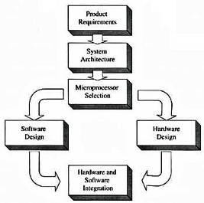

**Figure 2.4: Embedded System Design Process**

In this project, technique used for the software part is event-driven programming where finate state machine act as its tool. Basically, in event-driven model based program contains two types of objects which are passive and active object. Both of them have different function and characteristics. For passive objects, they run and generate message only when receiving some messages, whereas the actives objects are always running and can generate message without receiving any messages. Usually, hardware supported interrupt service routine can be categorized in active objects. If there is a case of external or internal interrupt event, the interrupt service routine will be called by the processors interrupt periphery. One of internal hardware event is a timer end analog-digital conversion. Using a program based on traditional event-driven model will gives an advantage which is automatic control of processor power consumption included in the model. From that, the response time of program will become the message processing plus the answer generation time if the message comes when the event queue is empty.

MATERIALS AND METHODS

The materials and design play a vital role in any project, we designed our IoT device with Robust in nature with withstanding vibrations also damping the noise. The 3D design is forefront research of many IoT devices also study of the various hazardous environmental area such as marshy land, radioactive area etc. So, in order to meet all the requirements these materials and several mechanisms have to be used.

## DC MOTOR

A DC motor as shown in figure 3.6 is an electromechanical energy alteration device. The working principle of a DC machine is when electric current flows through a coil within a magnetic field, and then the magnetic force generates a torque which rotates the dc motor.

Another name of a yoke is the frame. The main function of the yoke in the machine is to offer mechanical support intended for poles and protects the entire machine from the moisture, dust, etc. The materials used in the yoke are designed with cast iron, cast steel otherwise rolled steel. The pole of the DC machine is an electromagnet and the field winding is winding among the poles. Whenever field winding is energized then the pole gives magnetic flux.

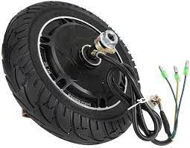

**Figure 3.1 DC Motor**

The materials used for this are cast steel, cast iron, otherwise pole core. It can be built with the annealed steel laminations for reducing the power drop because of the eddy currents. In this, the windings are wound in the region of pole core & named as field coil. Whenever current is supplied through field winding then its electromagnetics the poles which generate required flux. The material used for field windings is copper. The emitters of the lower transistors of each bridge are connected together rand the corresponding external terminal can be used for the connection of an external sensing resistor. An additional Supply input is provided so that the logic works at a low voltage. The control circuit accordingly decodes the signals from the position sensor.

## GSM MODULE

A GSM modem or GSM module is a device that uses GSM mobile telephone technology to provide a wireless data link to a network. GSM modems are used in mobile telephones and other equipment that communicates with mobile telephone networks. They use SIMs to identify their device to the network.

A customized Global System for Mobile communication (GSM) module is designed for wireless radiation monitoring through Short Messaging Service (SMS). This module is able to receive serial data from radiation monitoring devices such as survey meter or area monitor and transmit the data as text SMS to a host server. It provides two-way communication for data transmission, status query, and configuration setup. The module hardware consists of GSM module, voltage level shifter, SIM circuit and Atmega328P microcontroller. Microcontroller provides control for sending, receiving and AT command processing to GSM module.

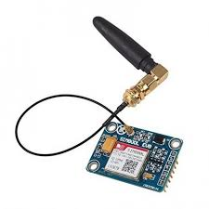

**Figure 3.2 GSM Module**

## ESP 8266

ESP8266 is a Wi-Fi SOC (system on a chip) produced by Express if system. It is a highly integrated chip designed to provide full internet connectivity in a small package. ESP8266 can be used as an external Wi-Fi module, using the standard AT Command set Firmware by connecting it to any microcontroller using the serial UART, or directly serve as a Wi-Fi enabled micro controller, by programming a new firmware using the provided SDK. The GPIO pins allow Analog and Digital IO, plus PWM, SPI, I2C, etc. This board has been around for almost a year now, and has been used mostly in IoT contexts, where we want to add connectivity for example to an Arduino project. A wide adoption has been facilitated by the very modest price, ranging from 2.50 to 10 USD depending on the features offered by the manufacturers.

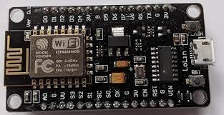

**Figure 3.3 ESP 8266**

## RELAY

A relay is an electrically operated switch. It consists of a set of input terminals for a single or multiple control signals, and a set of operating contact terminals. The switch may have any number of contacts in multiple contact forms, such as make contacts, break contacts, or combinations thereof.

Relays are used where it is necessary to control a circuit by an independent low-power signal, or where several circuits must be controlled by one signal. Relays were first used in long-distance telegraph circuits as signal repeaters: they refresh the signal coming in from one circuit by transmitting it on another circuit. Relays were used extensively in telephone exchanges and early computers to perform logical operations.

The traditional form of a relay uses an electromagnet to close or open the contacts, but other operating principles have been invented, such as in solid-state relays which use semiconductor properties for control without relying on moving parts. Relays with calibrated operating characteristics and sometimes multiple operating coils are used to protect electrical circuits from overload or faults; in modern electric power systems these functions are performed by digital instruments still called protective relays.

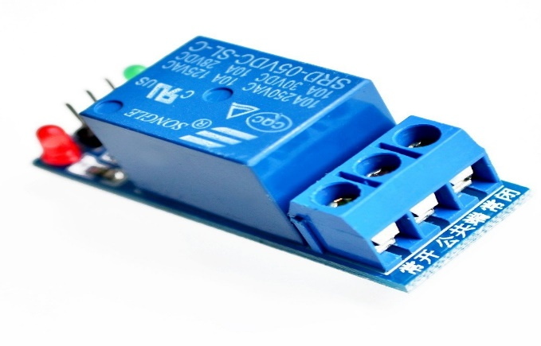

**Figure 3.4 Relay**

## Radio Frequency Identify (RFID)

The PN532 NFC RFID module is one of the more affordable NFC and RFID modules. The most common module/breakout board is the PN532 NFC RFID module (v3) This module is built around NXP PN532, and the maker break out almost all of the I/O pins of the NXP532 chip on this little module. This Arduino-compatible module has the following features:

* Supports II2, SPI, and high-speed UART (HSU)
* RFID reader/writer mode support for:
  + Mifare 1K, 4K, Ultralight, and DesFire cards
  + ISO/IEC 14443-4 cards such as CD97BX, CD light, DesFire, and P5CN072 (SMX)
  + Innovision Jewel cards such as the IRT5001 card
  + FeliCa cards such as RCS\_860 and RCS\_854
* Built-in PCB antenna (covered by white paint)
* 5- to 7-cm communication distance
* On-board level shifter
* Standard 5-V TTL for I2C/UART and 3.3-V TTL SPI (VCC 3.3 to 5 V)
* Works as an RFID reader/writer
* Works as a 1443-A card or a virtual card
* Supports NFC with Android phone

In the module, the I2C and HSU share the same pins. The definition of the I2C pins is labelled on top of the breakout board, while the HSU’s is labelled at the bottom. Although the HSU mode is configured as the default mode, with a small on-board SMD DIP switch, it becomes pretty easy to change among I2C, SPI, and HSU interfaces.

**[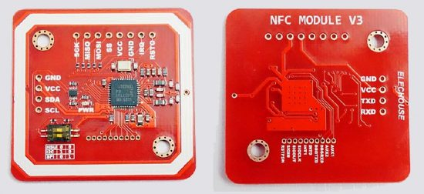](https://www.electroschematics.com/wp-content/uploads/2019/04/2-PN532-Module-V3_Closeup.jpg)**

**Figure 3.5 Radio Frequency Identify**

## LCD

The term LCD stands for liquid crystal display. It is one kind of electronic display module used in an extensive range of applications like various circuits & devices like mobile phones, calculators, computers, TV sets, etc. These displays are mainly preferred for multi-segment light-emitting diodes and seven segments. The main benefits of using this module are inexpensive; simply programmable, animations, and there are no limitations for displaying custom characters, special and even animations, etc. Passive infrared (PIR) sensors only detect infrared radiation and do not emit it from an LED. Passive infrared sensors are comprised of:

The features of this LCD mainly include the following.

* The operating voltage of this LCD is 4.7V-5.3V
* It includes two rows where each row can produce 16-characters.
* The utilization of current is 1mA with no backlight
* Every character can be built with a 5×8 pixel box
* The alphanumeric LCDs alphabets & numbers
* Is display can work on two modes like 4-bit & 8-bit
* These are obtainable in Blue & Green Backlight
* It displays a few custom generated characters

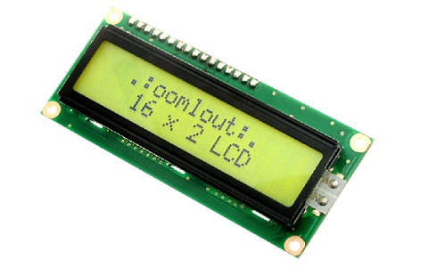

**Figure 3.6 LCD**

## Software Required

* Arduino IDE
* XAMPP server
* PHP Source Code
* RFID-RC522 Library
* NodeMcu ESP8266 Library and Board Manager

EXPERIMENTAL SETUP AND PROCEDURE

## Overview of IoT

Development of The RFID based IoT Device for Shared E-Vehicle system is developed using PHP, CSS, and Javascript. An RFID based IoT Device Using NodeMCU is a modern IoT Device. Hence, is a very interesting project. It can be useful in different places like schools, Colleges, industry and private organizations to register the Device of students, teachers, employees, etc. to tabulate monthly/daily riding hours automatically. When the person with the correct RFID card swipes his/her RFID tag, His/Her Vehicle starting time will be stored in system Log. Usually, when the same person swipes his/her RFID tag again, the system will save it as his/her ending time.

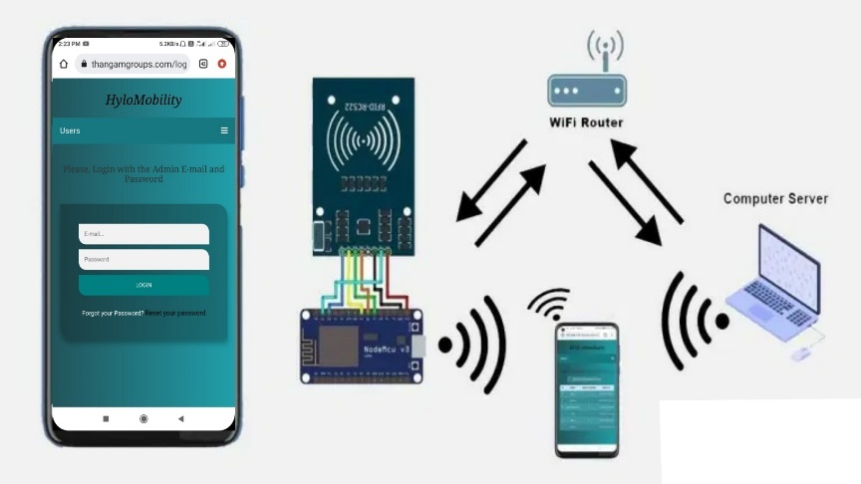

**Figure 4.1 Overview of IoT**

This IOT Device is developed with the IoT platform. We have used NodeMCU ESP8266 development board with MF-RC522 Module to send the card UID to the PHP Web app and store data into the website database. Basically, the admin plays an important role in the management of this system.

**Features:**

* Secured Login System
* Admin Panel
* User Entry Log
* User Management System
* Multiple Device Management System
* Filter the Log Data by Date, Time-In, Time-Out, and Department
* Export those filtered data to Excel

## Functionality Performed by users

Now, talking about the features of the RFID based IoT Device using NodeMCU. The home page displays the admin login page. Unless You login to the system, you won’t be able to browse other available options. Hence the system is secured. Basically, the design of this system project is pretty simple. Hence the user won’t find any difficulties while enrolling his/her data. The user needs to swipe his/her card or a keychain to maintain log that includes the entry time as well. The major functions provided to admin are mentioned below:

* Admin Login/Logout System
* Forgot Password for admin
* Edit and Update admin profile

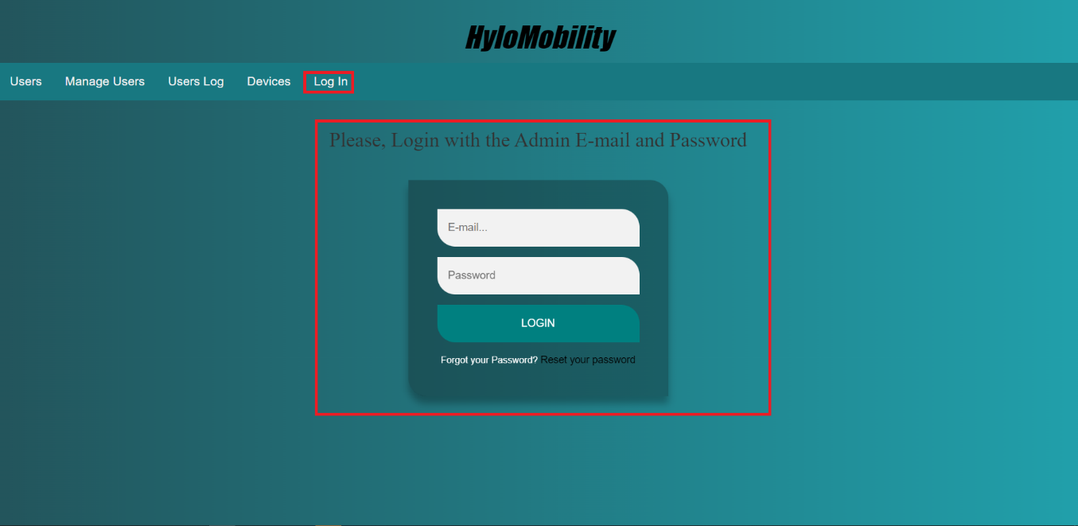

**Figure 4.2 Admin Panel Login System**

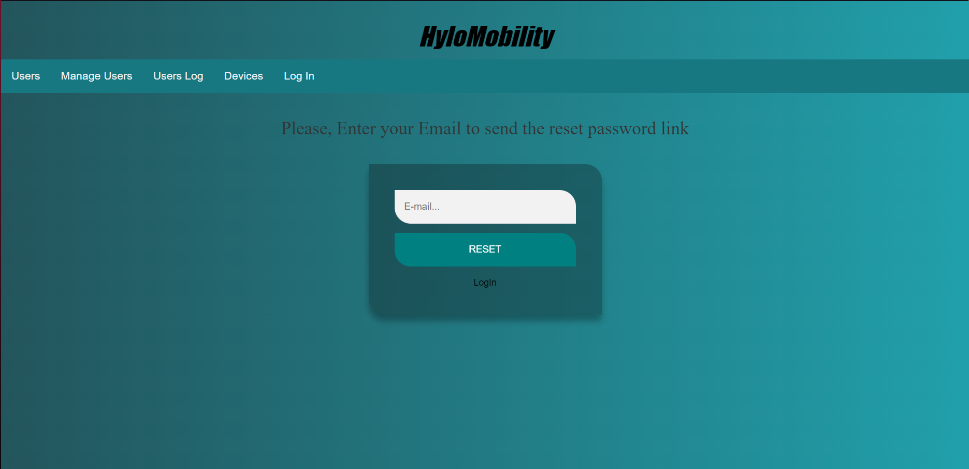

**Figure 4.3 Reset Admin Account Password**

**Manage Users:**

* View users
* Add New User
* Edit and update the existing users
* Remove Users

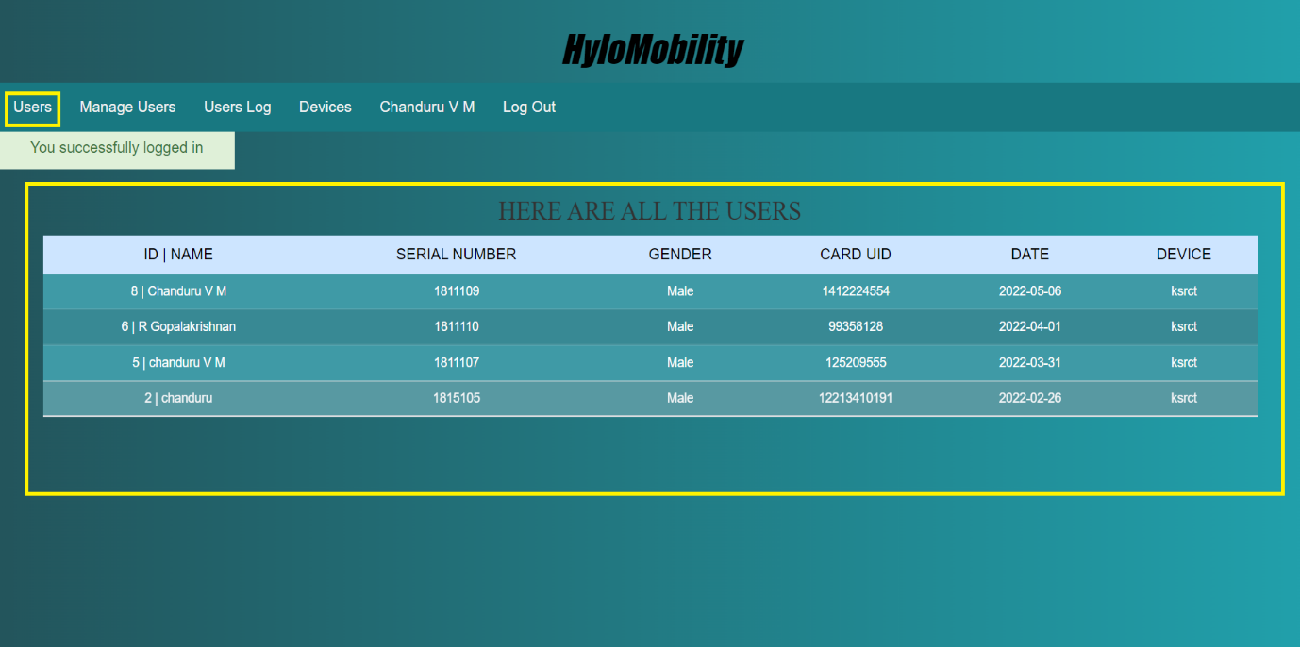

**Figure 4.4 View and Manage Users**

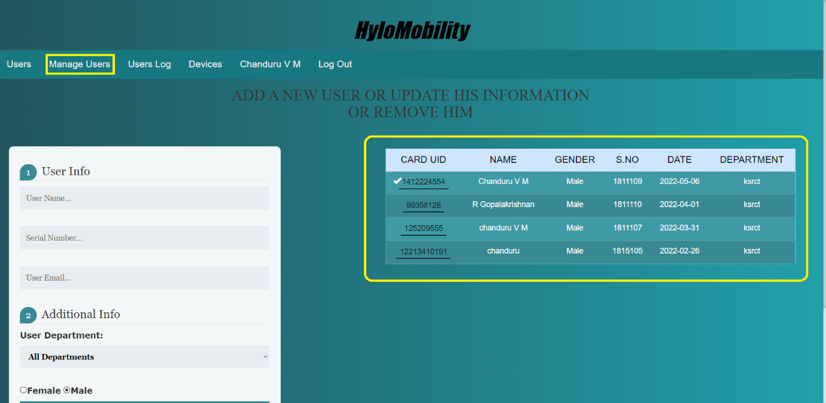

**Figure 4.5 User Management System**

From the admin panel, the admin can enroll new users, update and remove users from the user management system. Further, the admin can view all the records.

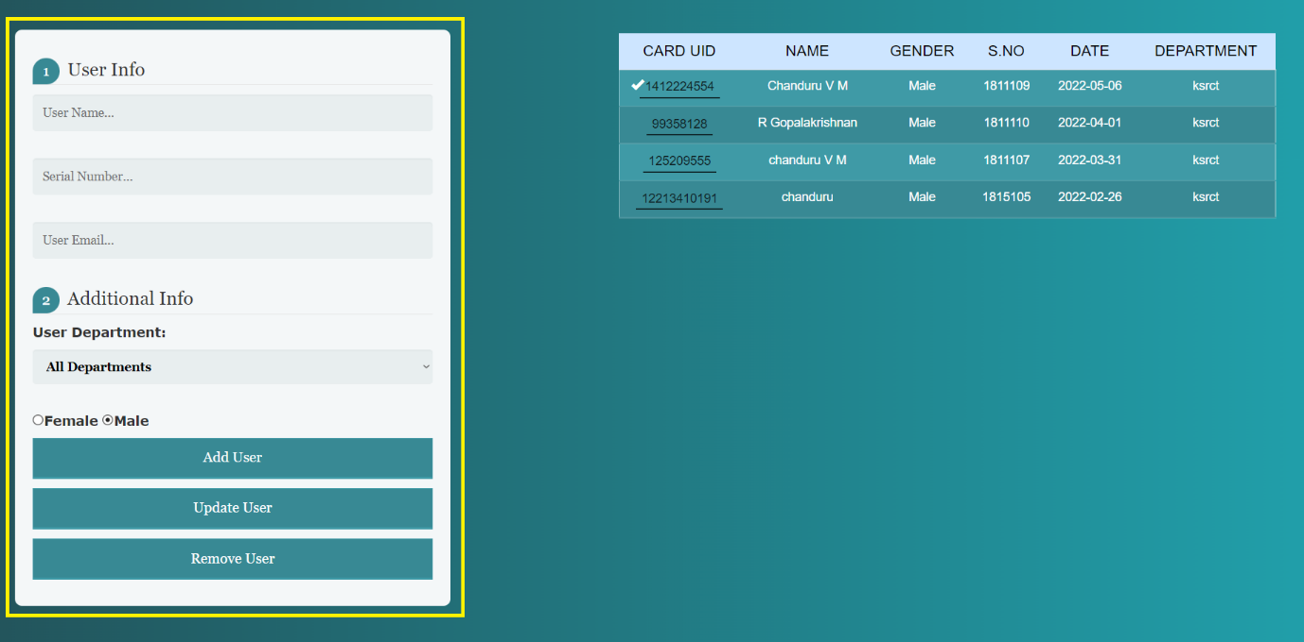

**Figure 4.6 Enroll New Users/Update/Remove**

**Manage Device:**

* Add new device
* Update existing device
* Delete device
* Update New token to the device
* Change the device mode (Enrollment mode: to register new users to the system, Attendance Mode: To record attendance of registered users)

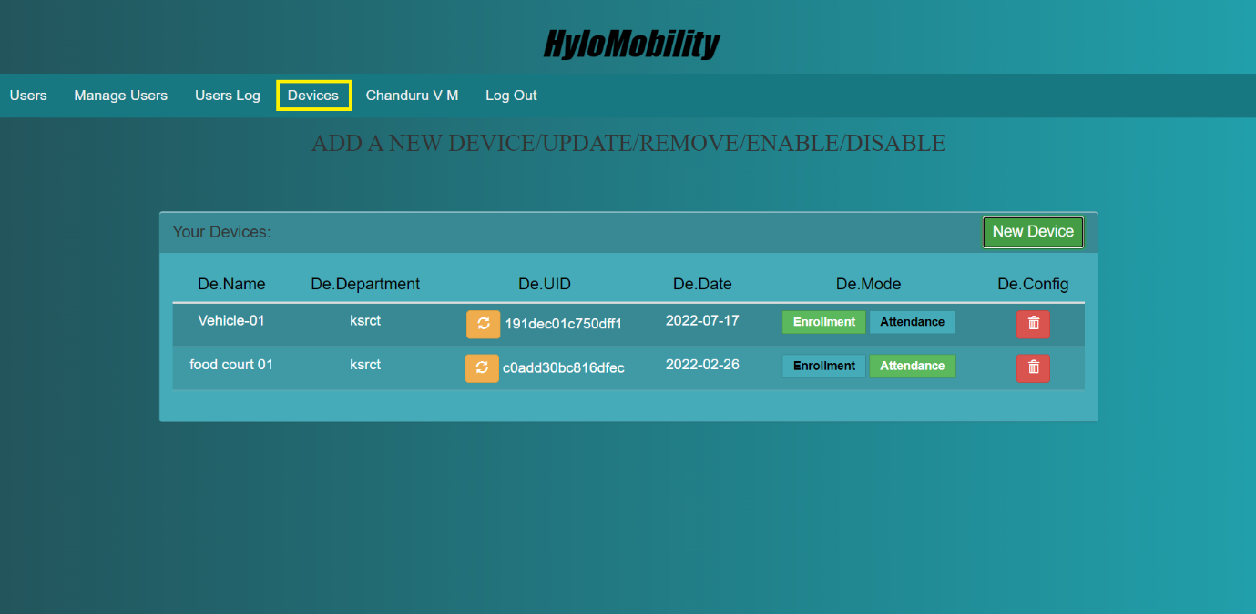

**Figure 4.7 Device Management System**

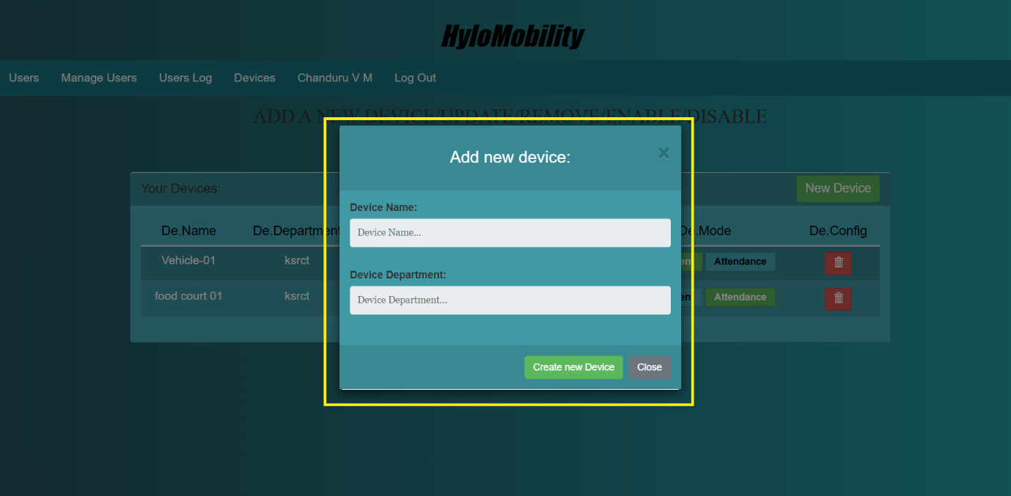

**Figure 4.8 Add New RFID Scanner Device**

Actually, from the devices section admin can add a new device, update the device, and remove the device. To add a new device you need to enter a device name and its department. Furthermore, you can also update the device token from the device UID Section.

**View Users Log:**

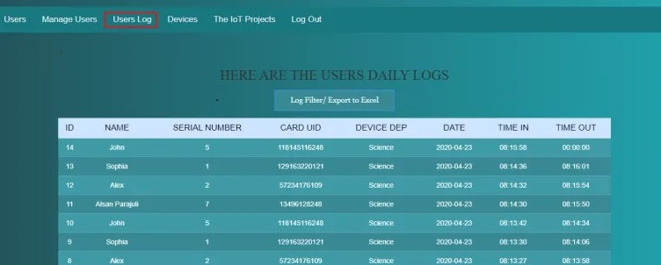

**Figure 4.9 View Users log**

From the user log menu, you can navigate to all the user’s logs data. You can view their arrival and Leaving time as well. Furthermore, It has more functions to filter your logs by user, date, arrival time, leaving time, and filter by different departments, etc. Hence, you can also export those data to excel.

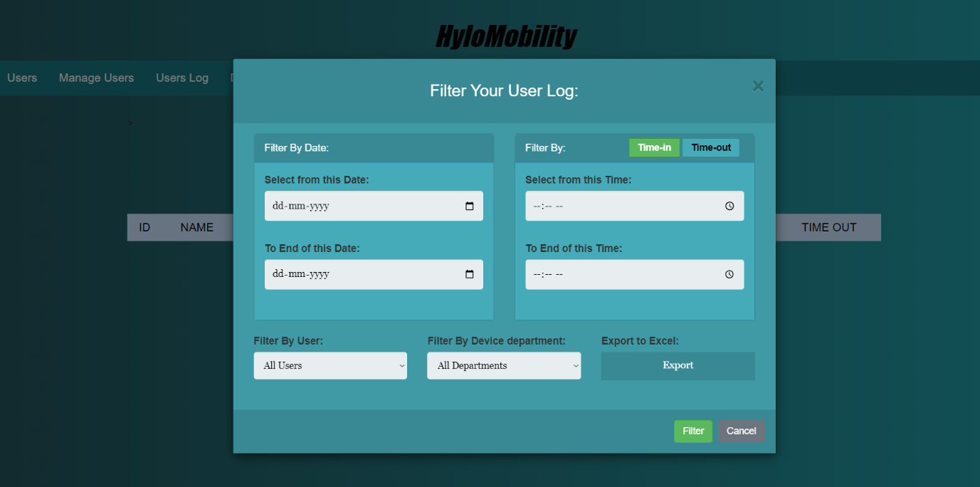

**Figure 4.10 Filter Users Log to export**

## Process Flow Diagram

The process flow diagram shown in the figure 4.10 consist of controller which is the brain of our project which is capable of give the IoT system

****

**Figure 4.11 Process Flow Diagram**

RESULTS AND DISCUSSION

Shared micro mobility service is system developed to satisfy the modern transportation needs by implementing the recent technologies that make the human life easier and convenient.

In this project Development of IoT Device for Shared E-Vehicle we have successfully developed and tested an IoT based system with the implementation of various technology such as RFID, GSM.GPS and Cloud. This developed system can be implemented in the real time vehicle for the purpose of shared mobility and vehicle sharing, this system is fixed in n numbers of vehicles and is been rented to the public users to use the vehicle at rental basis at needed times and all the data such as Vehicle id, User id, Vehicle start and stop time, Vehicle location, Vehicle SOC and Vehicle usage and Users vehicle usage data and various other information’s is been monitored with the use of the IoT system developed by us remotely.

Considering the results and the outcome from the developed project it is proved that it can be easily implemented at an affordable cost and works perfect in real time conditions when implemented in the Vehicle. The Gathered Data is been used to analyse the vehicle performance and the vehicle usage by the public people when implemented for the public utilisation.

CONCLUSION

The various technologies learned and understood from the literature review which we have collected, this project is been developed for the sole reason of adopting shared mobility in the upcoming transportation sector with the ease of users to access the vehicle. The developed system is compact and easy to implement for a large network of vehicle rental business. This developed system gives the most accurate output that is used for data validation. Implementation of this system gives the user the freedom to access the shared mobility vehicle independent of the smart phone which is been needed in the recent times to access the shared mobility services. The users can integrate this smart card with their daily use id cards and etc.

The proposed system can be upgraded to industrial level product by integrating High end configuration modules and IoT components so that the system works without any lags and will Work smoothly.

APPENDIX 1

**PROJECT PROTOTYPE PICTURE**

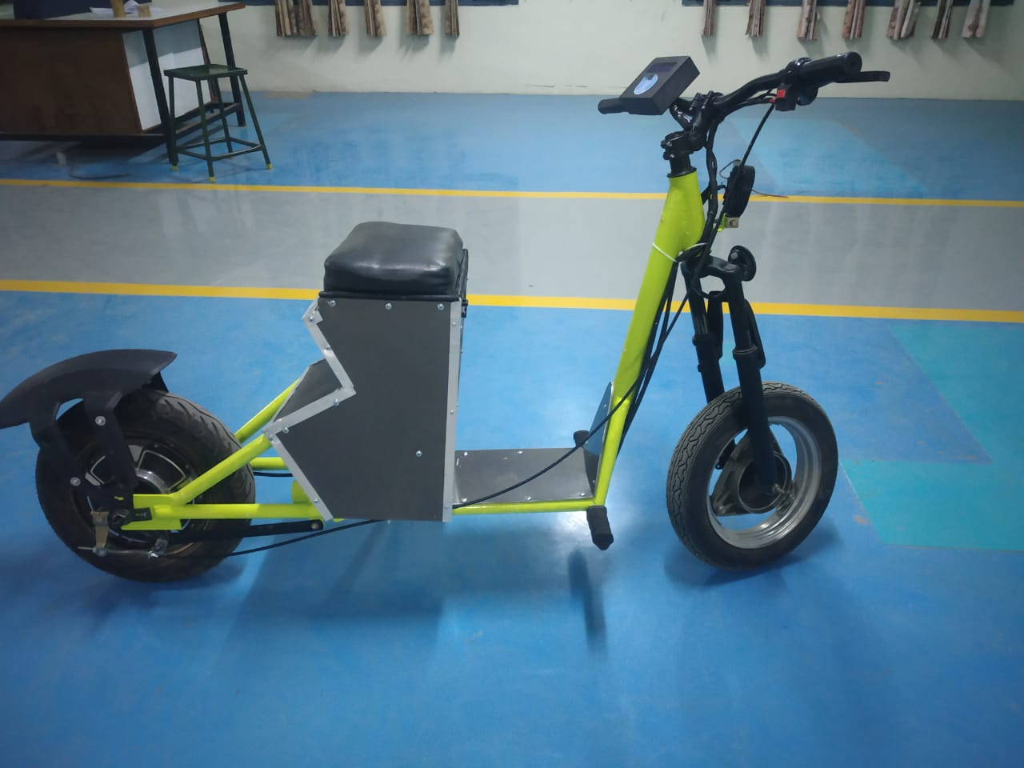

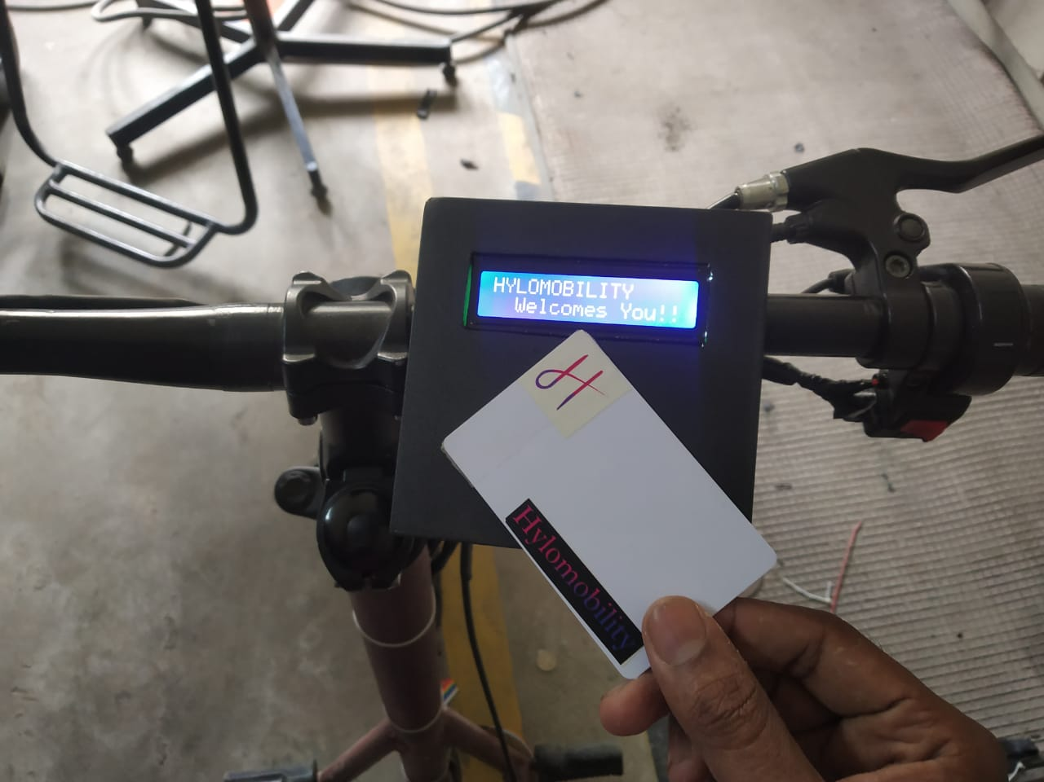

APPENDIX 2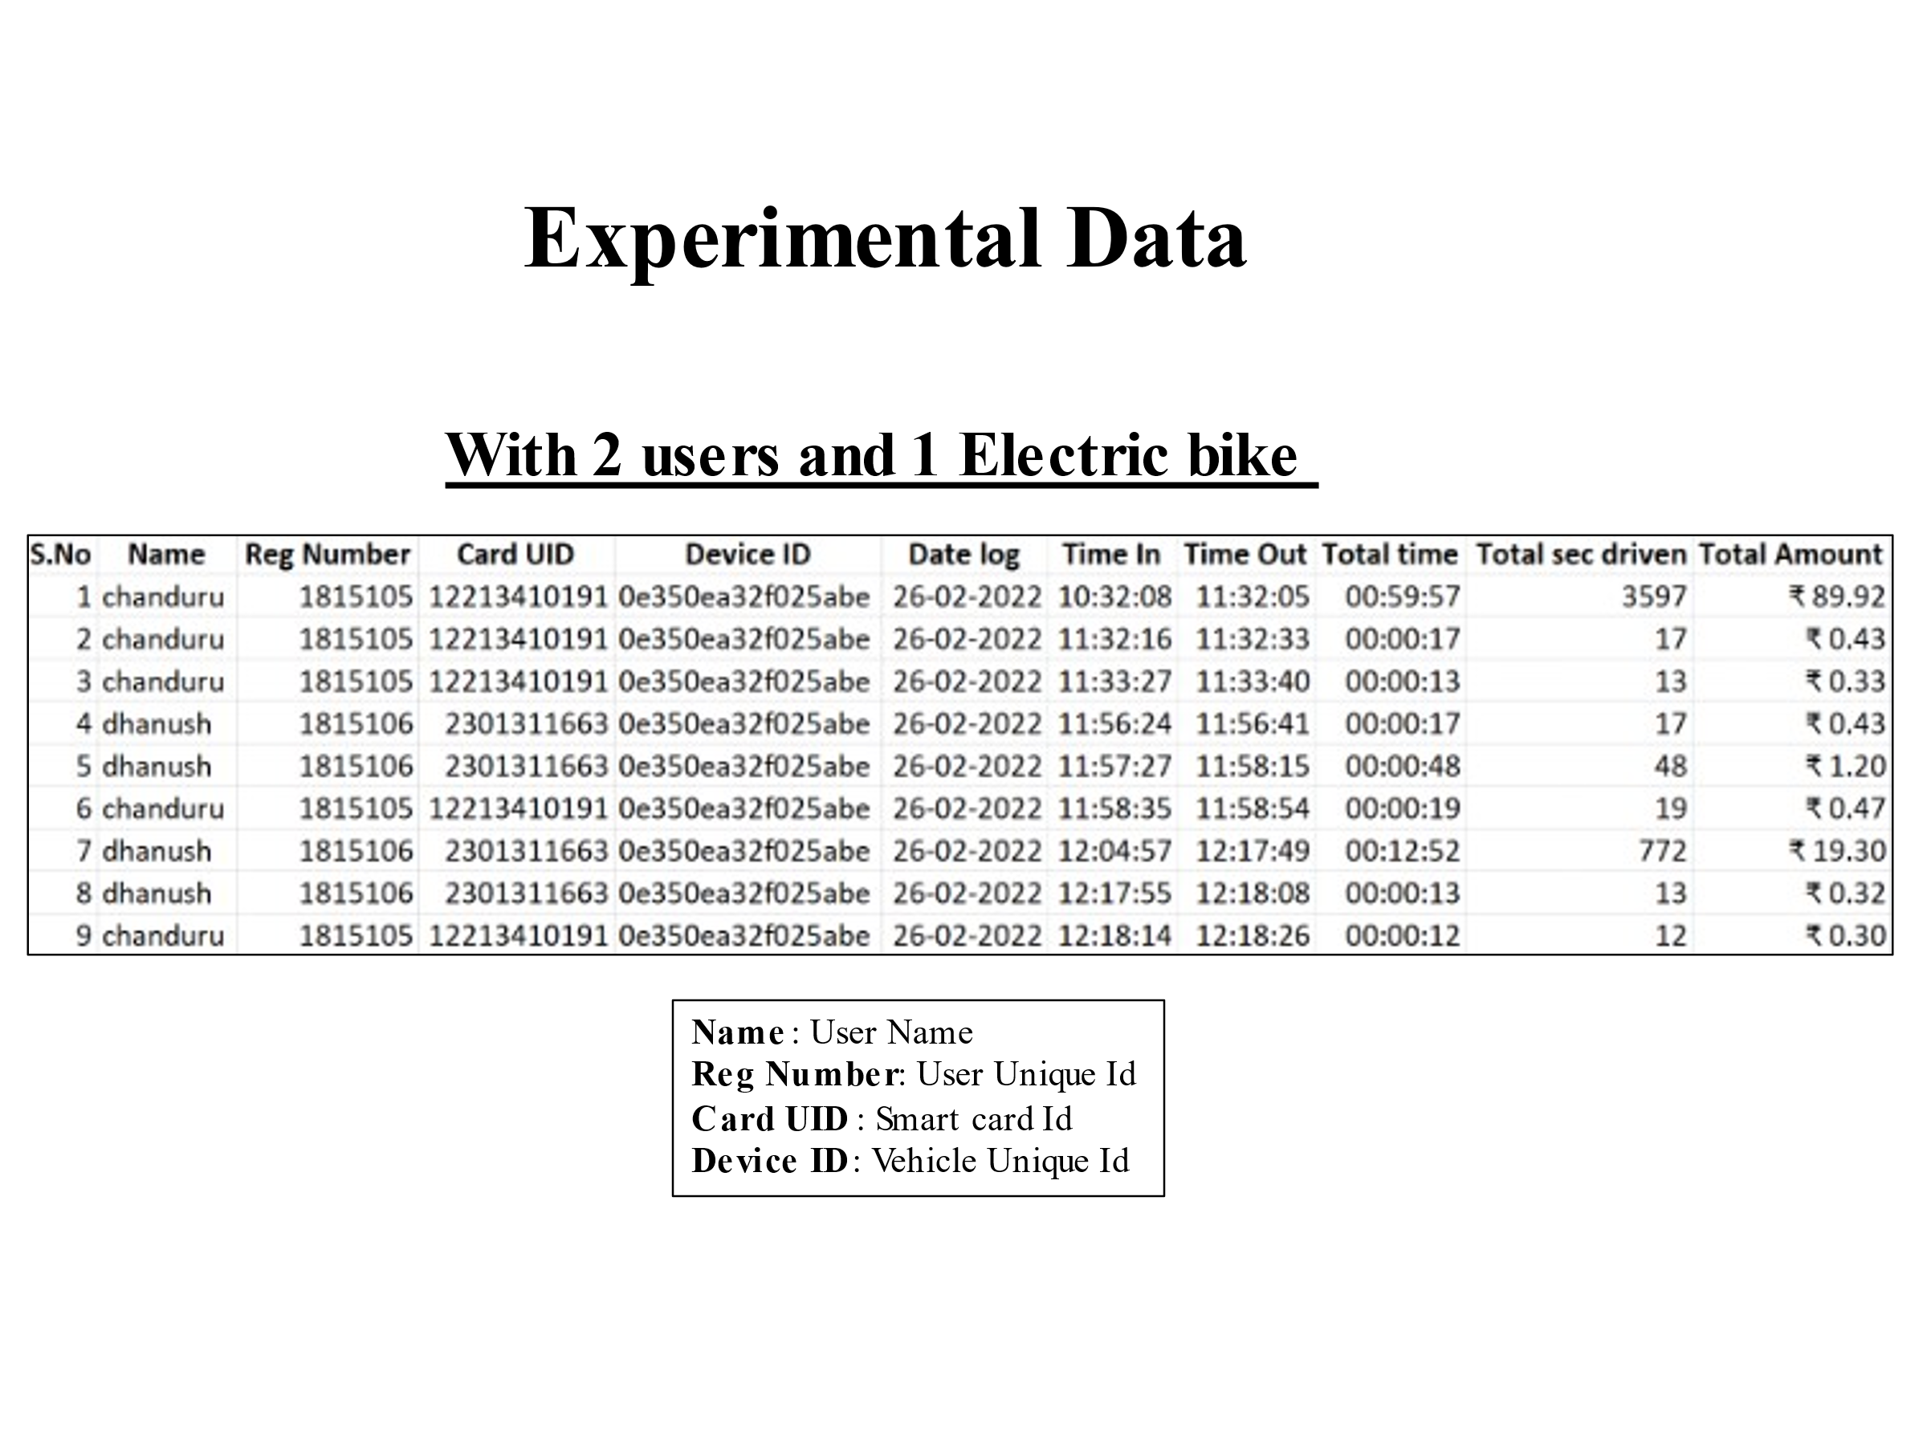

REFERENCES

[1] Xuan Gu, Dong Wang, Huanye Sheng, "RFID-Based Locating Management," 22nd International Conference on Advanced Information Networking and Applications, pp.18- 23, 2008.

[2] Elmar Zeeb, Steffen Pr¨uter and Frank Berger, "A Context Aware Service-Oriented Maintenance System for the B2B Sector," 22nd International Conference on Advanced Information Networking and Applications, pp.1381-1386, 2008.

[3] H. Baars, H.-G. Kemper and M. Siegel, "Combining RFID Technology and Business Intelligence for Supply Chain Optimization Scenarios for Retail Logistics," Proceedings of the 41st Annual Hawaii International Conference on System Sciences, pp.73-73, 2008

[4] Hwang, Hee Joung; Choi, Jin Tak, "Design of an AspectBased Framework to Improve the Dynamic Management of RFID Middleware," 7th IEEE International Conference on Computer and Information Technology, pp.955-960, 2007.

[5] Thomas Diekmann, Adam Melski and Matthias Schumann, "Data-on-Network vs. Data-on-Tag: Managing Data in Complex RFID Environments,". 40th Annual Hawaii International Conference on System Sciences, pp.222-233, 2007

[6] P.G. Ranky, "Engineering Management-Focused Radio Frequency Identification (RFID) Model Solutions," IEEE Engineering Management Review, vol.35, no.2, pp.20-30, 2007.

[7] R. Derakhshan, M.E. Orlowska and Xue Li, "RFID Data Management: Challenges and Opportunities," IEEE International Conference on RFID, pp.175-182, 2007.

[8] D.S. Kim, TH. Shin, & J.S. park, “A security framework in RFID multi-domain system”, Second International Conference on Availability, Reliability and Security, IEEE CS, Vienna, Austria, 2007

[9] B. Chowdhury and R. Khosla, "RFID-based Hospital Realtime Patient Management System," 6th IEEE ACIS International Conference on Computer and Information Science, pp.363-368, 2007.

[10] S.H. Yu, “RFID implementation and benefits in libraries,” The Electronic Library, Emerald Group Publishing Limited Vol. 25, pp. 54-64, 2007.

[11] S. Lahiri., RFID sourcebook, IBM Press, Westford, Massachusetts, 2006

[12] Yuhong Yan, Yong Liang and Han Liang, "Composing Business Processes with Partial Observable Problem Space in Web Services Environments," International Conference on Web Services, pp.541-548, 2006.

[13] Irene Y.L. Chen, Stephen J.H. Yang and Jia Zhang, "Ubiquitous Provision of Context Aware Web Services," IEEE International Conference on Services Computing, pp.60-68, 2006.

[14] Yacine Sam, Omar Boucelma and Mohand-Saïd Hacid, “Web services customization-A composition-based approach,” Proceedings of the 6th international conference on Web engineering, pp.25-31, 2006.

[15] C. Poirier, D. McCollum, RFID Strategy Implementation and ROI: A practical Roadmap to Success , J. Ross Publishing, Fort Lauderdale, Florida, 2006

[16] S. Lahiri., RFID sourcebook, IBM Press, Westford, Massachusetts, 2006.

[17] C. Poirier, D. McCollum, RFID Strategy Implementation and ROI: A practical Roadmap to Success , J. Ross Publishing, Fort Lauderdale, Florida, 2006.

[18] C. Heinrich, RFID and beyond: growing your business through real world awareness, Wiley, Indianapolis, Indiana, 2005.

[19] R. Imura, "Driving ubiquitous network - how can RFID solutions meet the customer's expectation," 10th IEEE Conference on Emerging Technologies and Factory Automation, 2005.